We are excited to present the Drayton Valley Chamber of Commerce Registration Forms. If you are receiving this package, it means that we are interested in your participation in exhibiting at the Business Expo. The Drayton Valley & District Chamber of Commerce is hosting our annual trade show, along with a Job Fair & Mamahood Market.

Please complete and return the forms with your credit card number or cheque payment (please retain a copy of your records) by March 30/26 to take part in our expo. Upon acceptance, confirmation will be forwarded to you, exhibit space will not be confirmed without full payment.

Registration Information - Please print clearly; all fields must be completed.
We, herein referred to as the ‘Exhibitor,’ offer to take for our use, space from the Drayton Valley and District Chamber of Commerce for the 2026 Expo. This contract is subject to the terms and conditions found in this package.

Company Name: | Contact Info:
Address: | City:
Province: | Postal Code:
Industry/ Service/ Products Affiliated with Company:
Special Requirements/ Notes:

Pricing & Space Information - Please refer to floor plan and legend on following pages.
Floor spacing will be first come, first serve basis so book early for the space you prefer. If power is needed, an extra $ 50.00 fee will be added to your space price, confirmed by March 30/2026. All pricing covers both days. Payments for Trade Show and job fair are to the Chamber of Commerce. Market payment to Mamahood.

Booth/Sponsorship Selection - Please make your selection according to information provided in this package.
Please fill in the following information based on the floor plan below. If you leave the following information blank, you may be allocated any booth.
Pricing
Booth Description | Members Price | Booth Description | Non-Member Price
10’ x 10’ Inline space curling rink floor | $200.00 for both days  Contact:  admin@dvchamber.ca | 10’ x 10’ Inline space curling rink floor | $300.00 for both days  Contact:  admin@dvchamber.ca
Job Fair curling Rink Lounge. Table & chair space  _________________________  Mamahood Market, Mackenzie Centre | $25.00 for both days  Contact:  ashton@rdcan.ca  ______________________  For pricing and details | Job Fair curling rink lounge. Table & Chair space  _______________________  Contact:  mamahoodmarketco@gmail.com | $ 50.00 for both days  Contact:  ashton@rdcan.ca  ___________________  Alycia, Alex & Brittney are the Market Host
Payment
Space Number 1st Choice: |  | Price:
Space Number 2nd Choice: |  | Price:
Sponsorship Package: |  | Price:
Subtotal
G.S.T
Grand Total
Payment Type: | Card Number:
Expiry: | Cardholder Name:
CVS: | Signature:

By signing this Registration Form, the Exhibitor hereby acknowledges and agrees that they have read, understood, agreed to, and will abide by the Conditions of the Contract located in this package.

Signature: Date:

NOTE: THE CURLING RINK FLOOR WILL HOST THE BUSINESS EXPO, THE LOUNGE WILL HOST THE JOB FAIR AND MACKENZIE CENTRE WILL HOST Artisan MARKET. ANYONE PURCHASING FLOOR SPACE FOR BUSINESS EXPO CAN USE THEIR SPACE FOR JOB RECRUITMENT ALSO ALONG WITH THEIR BUSINESS PART OF EXPO.

The Top 15 Reasons to Exhibit at a Trade Show

Promoting the Community and Economic Development in Drayton Valley:
A successful trade show means success for all businesses of Cochrane, which promotes economic development in your area. Participating in the trade show shows confidence and support for your business community.

Recruitment Opportunities:
Trade shows create a great opportunity to attract employees, volunteers, and distributors for your organization.

Generate Direct Sales:
Over 2000 attendees visit the Drayton Valley & District Chamber of Commerce Trade Show in 2024, giving you the opportunity to profit from sales directly at the show.

Generate Sales Leads:
Most exhibitors experience an increase in sales not only during a trade show, but after the show is over. Strategic participation in a trade show can leave you with hundreds of sales leads to follow up on, which will maximize the return on your marketing investment.

Cost Effective Marketing:
Other marketing media can be very costly. Compare the cost of TV, radio, website ads or links, social media ads, where you receive only one opportunity to push your product. On the other hand, trade shows allow you the opportunity to stand beside your product and market it fully to the audience that is right in front of you.

Market to an Audience that is Listening:
Trade shows are full of people seeking an interactive shopping experience. Attendees want your product to be shown, which creates a great atmosphere for marketing and selling.

Make your business memorable:
Repetition of your brand and image is an important part of marketing. Participating in a trade show helps you repeat your message to the public to instill your company’s image in the audience.

Keep an eye on the competition:
You don’t want your existing customers at a trade show where your competitors are if you are not there. Don’t let your customers forget about you or make a switch in your absence.

Create a new presence:
A trade show is a great way to get the word out about your product in a new market or location. Expand your reach with an out-of-town trade show.

Network:
Meet other members of your business community to get insider tips about the local market and other information from your colleagues. Trade shows are a great place to meet others who have common goals and business interests.

Demonstrate:
Trade shows are a marketing medium that allows you to demonstrate and display your products in ways that are not possible through other media. Demonstrate, sample, and display your product in an audience looking for such opportunities.

Market without Exhibiting:
If you can’t attend the trade show or the exhibit hall is already booked, there are many very cost-effective ways to show your support and create a presence at the trade show. You can find this information in this package.

RENTAL & CONTRACT EXECUTION

Full payment of the space rental fees is due at the time of contract signature and submission. Management reserves the right to determine the eligibility of exhibitors and appropriateness of exhibit prior to and during move-in dates. If an application is denied, a full refund of booth space will be made promptly. The applicant agrees that in the event space of greater square footage is selected, assigned, or allocated to applicant; the applicant consents to pay the additional amount required promptly upon receipt of notice to that effect. If space of less square footage is assigned, it will accept a refund based upon the reduced square footage. Full payment is compulsory in advance of move-in dates. Management reserves the right to resell space if above conditions are not adhered to. Space allotted and not occupied before the open of the trade show shall revert to the Drayton Valley & District Chamber of Commerce to be relet and occupied in any manner and for such purposes as show management may see fit. In such event, all payments made shall be retained by the Drayton Valley and District Chamber of Commerce.

CANCELLATION OF EXHIBIT SPACE

Cancellation by Exhibitor: All monies received will be fully refunded if written notification is received Drayton Valley & District Chamber of Commerce. by March 30/2026 For cancellations occurring after March 30/2026 all monies received from the registrant will be forfeited (whether the space is resold). For Cancellation at market contact Mamahood for details.

Cancellation by the Drayton Valley and District Chamber of Commerce: If the trade show is cancelled for any reason, the Drayton Valley and District Chamber of Commerce will not be liable to the exhibitor except to refund monies paid to date for exhibit space.

SPACE USAGE AND ALLOCATION

The space applied for is to be used solely for the exhibitor whose name appears on the application, and it is agreed that the applicant will not assign, sublet, or apportion the whole or any part of the space allotted. Assignment of space will only occur after the contract is completed and payment in full has been received at the office of the Chamber of Commerce. Show management reserves the right, at any time, without prior notification, to relocate exhibits and exhibitors when in Management’s opinion such moves are necessary to maintain the character and/or good order of the show. Management’s decision in this regard will be final.

LIABILITY

Responsibility of the Drayton Valley Chamber of Commerce and the Exhibit Facility: It is understood that all exhibit material.
will be delivered, maintained and removed at the exhibitor’s sole risk of all losses and damage whatsoever, and that neither Exhibit Installation Services Inc., the Drayton Valley and District Chamber of Commerce nor the Town of Drayton Valley facility or Can the Job Fair management or Mamahood Market shall be liable or responsible for any loss, damage, death or injury whatsoever; and that all claims for such loss, damage, death or injury are expressly waived by the exhibitor and the exhibitor shall forever indemnify, save harmless and defend Exhibit Installation Services Inc., the Drayton Valley and District Chamber of Commerce and the Town of Drayton Valley exhibit facility management, its officers, directors, employees or agents, Can Job Fair Management or Jenny Designs from and against any and all claims, demands, suits, judgements, liabilities, losses, damages and expenses resulting from, or incident to, any and all loss, damage, death or injury to persons or property arising out of, or in connection with, the exhibit or occupancy of the space allotted under the agreement.

Exhibitor’s Warranties: The exhibitor assumes entire responsibility and liability for losses, damages and claims arising out of injury or damage to exhibitors, displays, and equipment.
and other property brought upon the premises of Spray Lake Sawmills Family Sports Centre and shall indemnify and hold harmless the facility, its agents, servants, and employees from all losses, damages, and claims.

AMENDMENTS

Show Management shall make the final decision in adopting or enforcing any regulation deemed necessary prior to, during or after the show. All matters or questions, not specifically covered by the preceding Rules and Regulations, shall be subject solely to the decision of Show Management.

Payment Options:

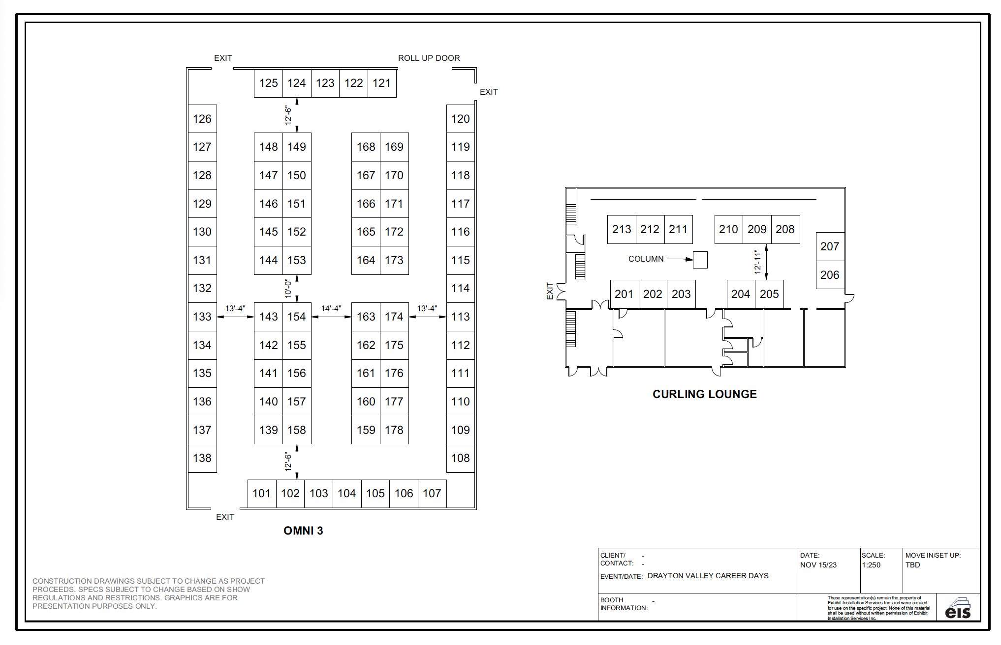
2026 Floorplan:

Expand your reach by participating in several exciting marketing and advertising options will be available at the 2026 expo. These unique opportunities allow your company to stand out from the rest by increasing your exposure before, during, and after the trade show. We invite you to participate as a sponsor even if you choose not to attend or exhibit in the show so that you can still have a presence and show your support.

Title Sponsorship $ 500.00
This prestigious sponsorship will get your company maximum exposure from your participation in the 2026 Trade Show. There are only three Title Sponsorships available. Costs will include the following:
Development of one feature area, activity or other with your company.
Honorable mention of your company name on all (non-reusable) wayfinding signage, handouts, posters, and media & web page. Honorable mention of your company name on all (pertinent) radio and interview advertising.

Marketing through Signage, $ 300.00
Show off your company name and booth number to everyone in the arena of the Trade Show with this marketing opportunity. Your contribution will be posted on signage upon entering trade show, the sign will tell everyone in the trade show that you are in the show and where they can find you.

Grab Bag Sponsorship, $ 50.00
If you would like to donate recyclable shopping bags for the trade show, we will hand them out at the door. Ideally, your company name or logo should be printed on the bag, which will provide huge exposure to your company within the trade show. Your name will be on the posters & our Web page as a sponsor of the expo.

COFFEE/SNACKS, Sponsorship, $ 250.00 for participants only Your logo etc. will be in hospitality room for all the vendors to view and on all posters used for advertising the event and web page as a sponsor of the event.

Completion of this form is Mandatory.

Complete this form with the names of all personnel who will be working in your space during the 2026 Business Expo. Return the completed form no later than April March 30/26 via email: admin@dvchamber,ca

Please complete the following information
Company Name:
Space Numbers: |  | On-site Main Contact:
Names of Booth Personnel
- 11.

- 12.

- 13.

- 14.

- 15.

- 16.

- 17.

- 18.

- 19.

- 20.

Please pick badges up at the Show Check-in upon arrival.

